**Educational Improvement Report**

**With**

**Power BI**

**By**

**Sachin Gunjal**

**INTRODUCTION**

The Ministry of Education's new initiative to enhance student performance in secondary schools is a commendable step towards building a brighter future for our nation. This report provides a comprehensive analysis of the key factors influencing educational outcomes across various states, based on a Power BI dashboard designed to visualize complex data sets. The objective is to transform raw data into a strategic asset, enabling data-driven decision-making to improve the quality of teaching and learning in crucial subjects like Mathematics, Science, and English. By leveraging the power of data visualization, we can identify trends, patterns, and outliers that might otherwise remain hidden in spreadsheets and databases. This report delves into the insights generated from the dashboard, which integrates data on student performance, teacher qualifications, school infrastructure, student attendance, and socio-economic backgrounds. Our analysis aims to pinpoint successful strategies, identify areas requiring immediate attention, and provide actionable recommendations to guide the Ministry's efforts. The ultimate goal is to foster an educational ecosystem where every student has the opportunity to reach their full potential, supported by skilled teachers, adequate resources, and a conducive learning environment. This document will serve as a critical tool for policymakers and educators to understand the multifaceted challenges and opportunities in our education system and to devise targeted interventions that can bring about meaningful and sustainable improvements.

**KEY FINDINGS**

* **Student Performance Variation:** There is a noticeable variation in average student scores across different states, with some states performing significantly better than others.
* **Impact of Socio-Economic Factors:** Socio-economic factors, particularly parental education level, have a strong positive correlation with student scores. Students with parents having post-graduate education tend to have the highest scores.
* **Teacher Quality Matters:** The analysis suggests a link between teacher qualifications (B.Ed, M.Ed, PhD) and student performance, although this needs a more in-depth statistical analysis to confirm causality. States with a higher concentration of highly skilled teachers show promising educational outcomes.
* **Infrastructure's Role:** School infrastructure, including the availability of computers, internet access, and libraries, varies considerably across states. While a direct causal link to student performance is not explicitly shown, states with better infrastructure tend to perform well
* **Attendance and Performance:** There is a positive correlation between student attendance and academic performance. Higher attendance is generally associated with higher student scores.
* **Teacher Experience Distribution:** A significant portion of the teaching workforce consists of senior teachers (52K, or 51%) , while newly joined teachers make up a very small fraction.

**ACTIONABLE INSIGHTS**

* **Targeted Interventions for Low-Performing States:** The Ministry should focus on states with lower average student scores by providing additional resources, teacher training programs, and infrastructure development initiatives.
* **Bridge the Socio-Economic Gap:** Implement programs to support students from disadvantaged socio-economic backgrounds. This could include scholarships, free tutoring, and counseling services to mitigate the impact of socio-economic disparities on educational outcomes.
* **Invest in Teacher Development:** Enhance teacher quality through continuous professional development, training programs, and incentives for higher qualifications. Special focus should be given to states with a lower proportion of highly skilled and qualified teachers.
* **Upgrade School Infrastructure:** Prioritize the upgradation of school infrastructure, especially in rural and underserved areas. Ensuring access to computers, the internet, and well-equipped libraries is crucial for modern education.
* **Promote Regular Attendance:** Launch campaigns and initiatives to raise awareness about the importance of regular attendance. Schools should work with parents to address the root causes of absenteeism.
* **Promote Best Practices:** Identify and document the best practices of high-performing states and schools to create a model for improvement that can be replicated across the country.

**METHODOLOGIES AND APPROACHES**

This report is based on a descriptive analysis of the visualizations presented in the Power BI dashboard. The dashboard integrates and analyzes multiple datasets, including:

* Student performance data
* Teacher qualification and training data
* School infrastructure and resource availability data
* Student attendance records
* Socio-economic background of students

The analysis involved a systematic review of each visual to identify key trends, patterns, and correlations. The insights generated are based on the visual representation of the data and aim to provide a clear and concise understanding of the state of education across different states. The approaches used in the dashboard's creation, as outlined in the project description, include data preparation (merging, cleaning, and handling missing values), exploratory data analysis using pivot tables and charts, and statistical analysis to identify correlations and trends.

**INSIGHTS**

This section provides a detailed explanation of each visual presented in the Power BI dashboard.

**Sheet 1: EDUCATION**

* **Visual Name:** KPIs

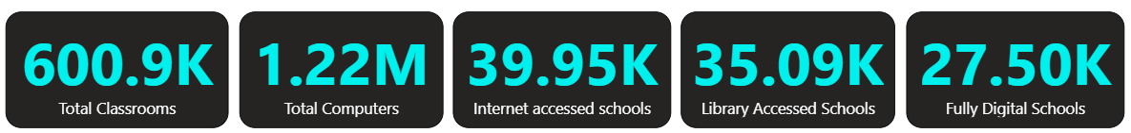

* **Explanation:** This section provides a high-level overview of the educational infrastructure
* Total Classrooms: 600.9K
* Total Computers: 1.22M
* Internet accessed schools: 39.95K
* Library Accessed Schools: 35.09K
* Fully Digital Schools: 27.50K

These numbers indicate a significant investment in educational infrastructure, although the distribution and accessibility of these resources across states need further examination.

* **Visual Name:** Average Attendance & Score by State (Bar Chart)

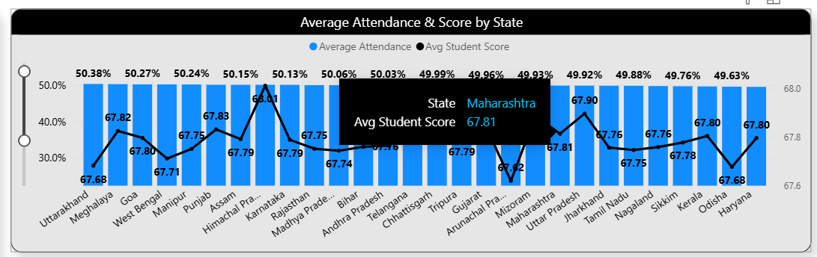

* **Explanation:** This chart compares the average student attendance and scores across various states. For instance, Himachal Pradesh has a high average student score of 68.01 with an attendance of 50.15% , while West Bengal has a lower average score of 67.71 with a higher attendance of 50.27%. The chart reveals that while there is a general trend of higher attendance correlating with better scores, this is not always the case, suggesting that other factors are also at play.
* **Visual Name:** Most Skilled Teachers (List)

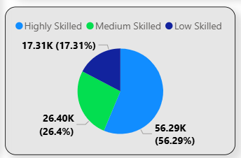

* **Explanation:** This visual lists the states with the most skilled teachers, including Karnataka, Maharashtra, Tamil Nadu, Kerala, and Haryana
* This qualitative assessment highlights states that could serve as models for teacher development programs.
* **Visual Name:** Parents Education Level (List)

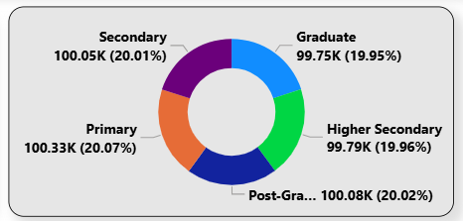

* **Explanation:**

Primary: 100.33K (20.07%)

Secondary: 100.05K (20.01%)

Post-Graduate: 100.08K (20.02%)

Higher Secondary: 99.79K (19.96%)

Graduate: 99.75K (19.95%)

The data indicates a relatively even distribution of parents across these five educational categories, with each category accounting for approximately 20% of the total

* **Visual Name:** Digitally Best Schools (List) and most skilled teachers



* **Explanation:** This list showcases states with the best digital infrastructure in schools. States like Karnataka , Maharashtra , and Tamil Nadu are recognized for their digitally advanced schools.

**SHEET 2: TEACHER'S IMPACT ANALYSIS**

* **Visual Name:** Total Teachers (Card)
* **Explanation:** The dashboard indicates a total of 100K teachers are included in this analysis.

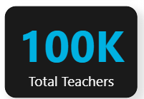

* **Visual Name:** Teachers Qualification By State (Stacked Bar Chart)

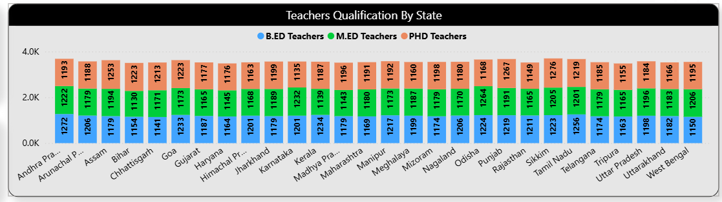

* **Explanation:** This chart breaks down the qualifications of teachers (B.Ed, M.Ed, PhD) by state. For example, in Andhra Pradesh, there are 1272 B.Ed teachers, 1222 M.Ed teachers, and 1193 PhD teachers. The chart shows a diverse landscape of teacher qualifications across the country, which can be correlated with student performance data to understand the impact of teacher education.
* **Visual Name:** Skilled Teacher by State (Map)

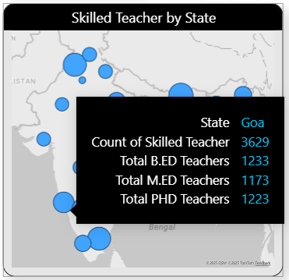

* **Explanation:** This map visualizes the geographical distribution of skilled teachers across India. The concentration of skilled teachers appears to be higher in certain regions, which can inform decisions about teacher deployment and training.
* **Visual Name:** Teachers Experience level by state (Bar Chart)

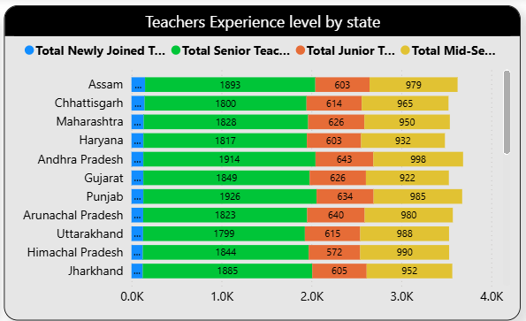

* **Explanation:** This chart shows the distribution of teachers by experience level (Newly Joined, Junior, Mid-Senior, and Senior) in various states. For example, in Andhra Pradesh, there are 1914 senior teachers and 643 junior teachers. This helps in understanding the experience profile of the teaching workforce in each state.
* **Visual Name:** Total Teachers by Experience Level (Donut Chart)

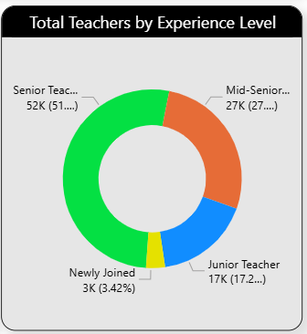

* **Explanation:** This chart provides an overall view of the experience level of the entire teacher population in the dataset. It shows that Senior Teachers constitute the largest group with 52K (51%) , followed by Mid-Senior teachers with 27K (27%) , Junior Teachers with 17K (17.2%) , and Newly Joined teachers with 3K (3.42%).

**SHEET 3: INFRASTRUCTURE IMPACT**

* **Visual Name:** Total Classrooms & Teachers by State (Bar Chart)

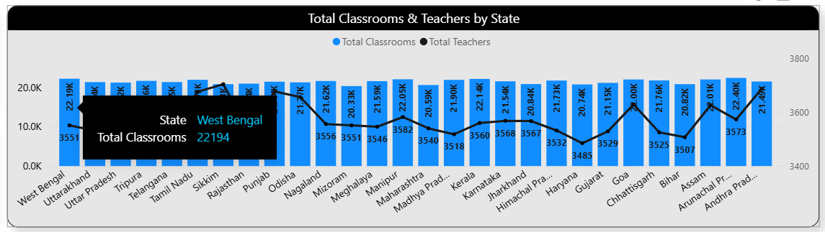

* **Explanation:** This chart compares the number of classrooms and teachers in each state. For example, West Bengal has approximately 22.19K classrooms and 3551 teachers. This visual can help in assessing the student-teacher ratio and classroom availability across states.
* **Visual Name:** Total Classrooms, Computers and Internet accessed schools by State (Line and Bar Chart)

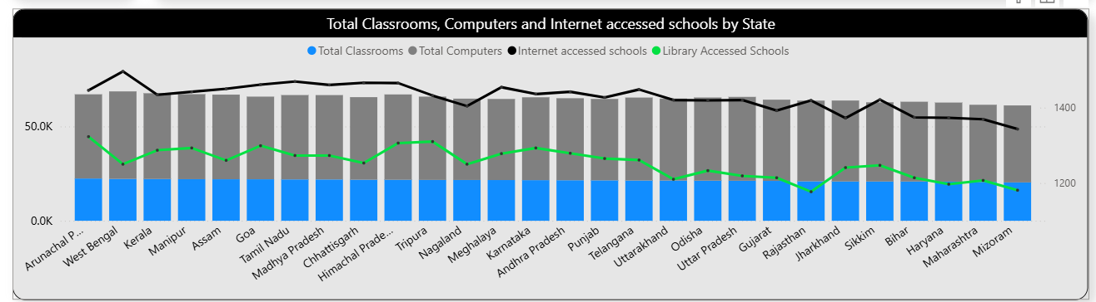

* **Explanation:** This comprehensive visual provides a multi-dimensional view of school infrastructure by state. It plots the total number of classrooms, computers, and schools with internet and library access. This allows for a comparative analysis of infrastructure across states, which can be correlated with student performance data.

**SHEET 4: ATTENDANCE VS PERFORMANCE**

* **Visual Name:** Avg Student Score by Attendance (Scatter Plot)

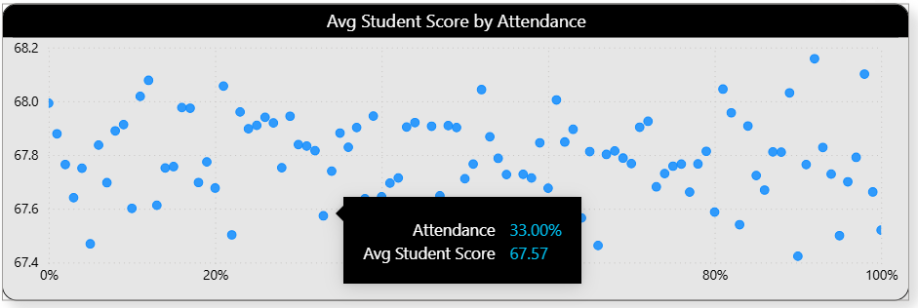

* **Explanation:** This scatter plot visualizes the relationship between average student scores and attendance. The plot shows a positive correlation, where higher attendance generally corresponds to higher scores. However, the scattered nature of the points suggests that attendance is not the sole determinant of student performance.
* **Visual Name:** Avg Student Score by Attendance Category (Donut Chart)
* 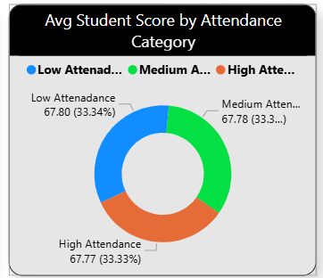**Explanation:** This chart categorizes students into low, medium, and high attendance groups and shows the average score for each. The average score for the high attendance group is 67.77 (33.33%) , for the medium attendance group is 67.78 (33.3%) , and for the low attendance group is 67.80 (33.34%). This chart seems to contradict the scatter plot, showing very little difference between the average scores of the different attendance groups. This might be due to the way the categories are defined or could indicate that the impact of attendance on average scores is minimal when data is aggregated this way.
* **Visual Name:** Student score related to Parents education Level (Bar Chart)

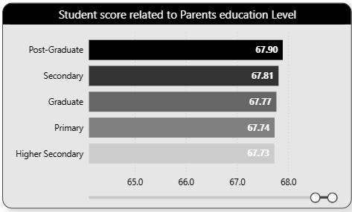

* **Explanation:** This chart clearly demonstrates the influence of parents' education on student scores. Students whose parents have a Post-Graduate degree have the highest average score of 67.90 , followed by those with parents having a Secondary level education with a score of 67.81. This highlights the significant role of the home environment and parental background in a child's academic success.
* **Visual Name:** Avg Student Score by Family Income (Pie Chart)
* 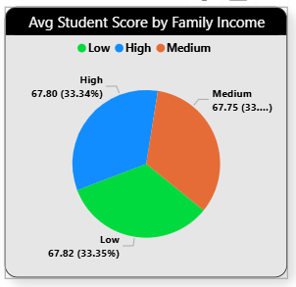**Explanation:** This pie chart shows the average student score based on family income level (Low, Medium, High). Students from high-income families have an average score of 67.80 , while those from low-income families have a slightly higher average score of 67.82. Students from medium-income families have an average score of 67.75. The small differences in scores suggest that family income, as categorized here, may not be as strong a predictor of student scores as parental education level.

**SHEET 5: ALL SCHOOL DATA IN TABULAR FORMAT**

* **Visual Name:** All School Data in Tabular format (Table)

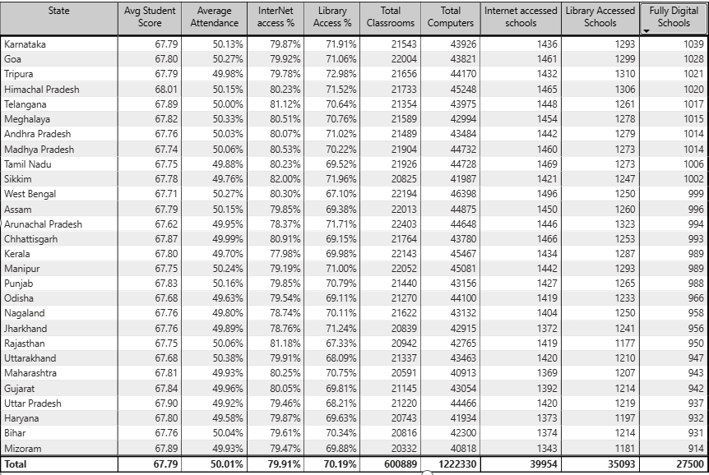

* **Explanation:** This table provides the detailed raw data for each state, including average student score, average attendance, internet access percentage, library access percentage, and counts of classrooms, computers, and different types of schools. This table serves as the underlying data for many of the visualizations in the dashboard and can be used for more granular analysis and verification of the insights presented.

**CONCLUSIONS**

The Power BI dashboard provides a powerful and intuitive platform for analysing the complex factors that shape educational outcomes in India. The visualizations clearly indicate that a multi-pronged approach is necessary to drive meaningful improvement. While investments in infrastructure are crucial, the analysis underscores the paramount importance of teacher quality and the profound influence of students' socio-economic backgrounds. The insights generated from this dashboard can empower the Ministry of Education to move beyond one-size-fits-all policies and develop targeted, data-informed strategies that address the specific needs of different states and student populations. By continuing to leverage data analytics, the Ministry can monitor the impact of its initiatives, make real-time adjustments, and ultimately create a more equitable and effective education system for all. The path to educational excellence is a continuous journey of improvement, and this data-driven approach provides a clear roadmap for the way forward.